Connor Colbert

Dr. Byrd

Introduction to Data Visualization

31 March 2022

W.E.B. Du Bois’s Visualization Reimagined:

How America’s Black/Mixed Population is Distributed in 2020

The field of data visualization may seem as though it is a recent phenomenon to some; however, through Du Bois’s visualizations, it has been widely influential for some time. Du Bois brought to light many of the social struggles for black Americans in the United States through his visualizations (or “plates”). In this assignment, I took on the task of recreating his 38th plate listed in *W.E.B. Du Bois’s Data Portraits: Visualizing Black America*. This plate depicts the population distribution, by square mile, of black Americans across the continental United States in 1890. In 1890, the data indicates a much smaller population than what is present in the United States today, as represented in the revised graphic.

To start, I gathered my data from the United States Census Bureau’s data from 2020 on race population data across all states and Puerto Rico. During the mining stage, I removed all population aside from those who indicated as being “Black or African American” or having a mixed racial makeup. Additionally, the Census Bureau’s data included The District of Columbia (Washington D.C.); however, due to its small size (and not being considered a state), it resulted in a significant outlier that skewed the entirety of the visualization and was removed. In comparison to the previous visualization, the map is representative of the modern United States’ borders and includes Alaska and Hawaii, as well. A critique I received from others is that Alaska seems to be an outlier, though not influencing the visualization as much as D.C. did. Additionally, I was told that the text for Connecticut was missing, so I tended to both changes in an updated visualization.

Upon analyzing the new visualization, it appears that the overall population of black Americans in the United States has increased greater than tenfold in some states. Maryland is one of the most populous states for black Americans, which, when compared to Du Bois’s visualization, is something that has held true across both.

Plate 38 featured *W. E. B. du Bois's Data Portraits: Visualizing Black America*

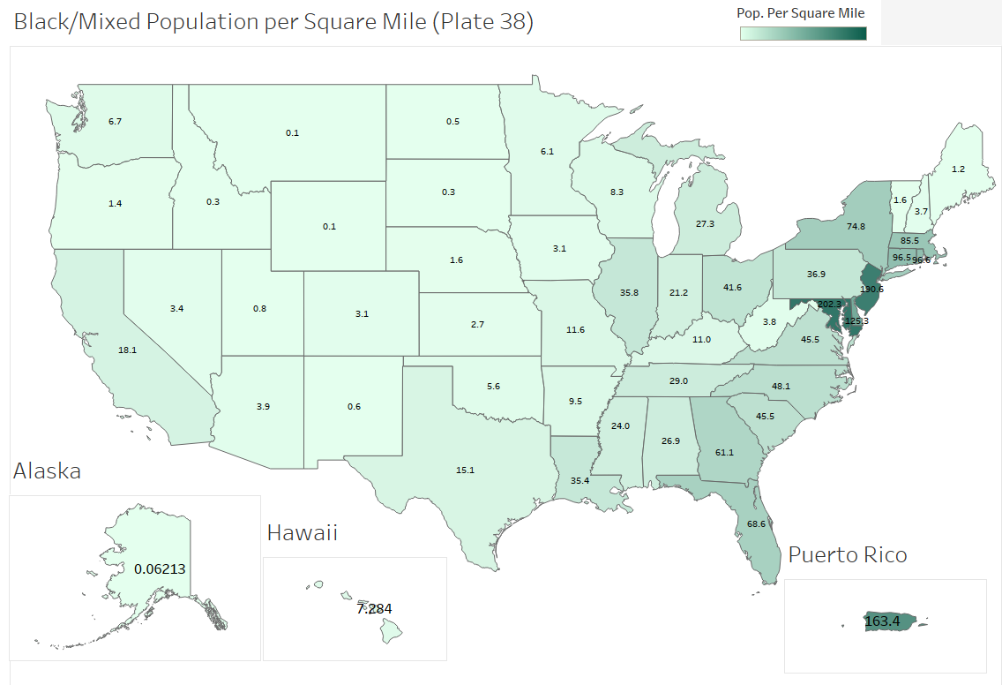

A visualization representing the black/mixed population of Americans across the United States. All population data is per the square mile, so it is indicative of the population density of a given state/territory. Visualization created in Tableau, using Excel for data management.

Data gathered from: [The United States Census Bureau](https://data.census.gov/cedsci/table?y=2020&d=DEC%20Redistricting%20Data%20%28PL%2094-171%29&tid=DECENNIALPL2020.P1)